

The world’s helping hand

Table of Contents

1.0 Executive Summary……………………………………………………...4

2.0 Company Description…………………………………………………….5

2.1 Mission Statement

2.2 Legal Structure

2.3 Effective Date of Business

2.4 Company Location

2.5 Company Governance

2.6 Immediate Development Goals

2.7 Overview of Financial Status

3.0 Industry Analysis………………………………………………………….7

3.1 Descriptions, Trends, & Strategic Opportunities

4.0 Target Market……………………………………………………………...8

4.1 Target Market Analysis

5.0 Competitive Analysis……………………………………………………10

5.1 Key Competitors

5.2 Potential Future Competitors & Barriers to Entry

6.0 Marketing Plan & Sales Strategy……………………………………..13

6.1 Key Message

6.2 Message Delivery

6.3 Sales Procedures & Strategies

7.0 Operations………………………………………………………………..16

7.1 Business Facilities

7.2 Production Plan

7.3 Workforce Plan

7.4 Impact of Technology

8.0 Management & Organization…………………………………….……22

8.1 Key Employees, Board of Directors, & Human Resources

8.2 Identifying, Securing, & Recruiting Key Participants

8.3 Compensation & Incentive Plan

9.0 Long Term Development……………………………………………….23

9.1 Goals

9.2 Risk Analysis

9.3 SWOT Analysis

10.0 Financials……………………………………………………………..….26

10.1 Accounting System

10.2 Initial Expenditures & Investment Request

10.3 Monthly Cash Flow Statements

10.4 Monthly Income Statements

10.5 Annual Income Statements

10.6 Breakeven Analysis

11.0 Appendix………………………………………………………………….30

**1.0 Executive Summary**

With the rise of the digital era, humans can do things such as order items online, communicate loved ones at a distance, and even enter the virtual worlds of gaming. As time advances, more and more entrepreneurs emerge with their own innovation corresponding with how the world should be. Upon examining the current world and US economy, there is one sector that so obviously lacks the benefits provided by the massive technological innovation of the twenty-first century. This sector is the on-demand human service industry. According to sources, over 60% of Americans daily require some fort of on-demand service, whether it’s a tutor, babysitter, or just someone to run some errands. Currently there is little to zero supply of on-demand human service, and that’s where Help! comes in.

Help! is a mobile application that will enable users to request services from providers with the tap of a button. The idea is that if a user, for example, needs someone to mow their lawn, they would simply put out a request while offering a set amount of money, and service providers bid for the job, similar to online freelancer sites. Once the requester has chosen a service provider based on their asking price and their past reviews, the user can accept the offer and their lawn will be mowed for the agreed upon price with a small fee coming to Help! from the requesting side. With a fully functional application, people will no longer have to deal with the hassle of finding a babysitter for the night or finding a good tutor to teach them the subject, and instead they’ll be able to focus on the important aspects of their lives.

On-demand service is an industry that has been flat out explosive in the past couple years. Applications such as Uber and AirBnb have transformed the way people live out their lives. According to PeerBits, 42%, or 87 million Americans have used one of the on-demand service applications currently available. This specific industry is experiencing 50% year on year growth in terms revenue. The last time a growth of this size was experienced was during the boom of the personal computer, which now, after the immense initial growth, is something that is present in almost every home. The next step in this industry is the ability to provide human service, as it is shown by demographics that 80% of Americans would benefit from a network of people they could rely on for services (QuickSource). Help! will create that required network from not just people you know, but from every person around the country.

The Puget Sound area in Washington state will serve as a starting point for Help! to gain traction from both service providers and requesters. The area was chosen because of it being already technologically advanced, and prepared due to the overwhelming number of software companies such as Microsoft & Amazon. Consumers will be willing and excited to use a product which enhances and empowers their lives. Help! will acquire initial capital from Madrona Venture Group, all to be paid back in the form of equity. The total amount Help! will be asking for $1.04 million in initial capital for a total of 20% equity in the company, valuing the innovation at $5.2 million, which will be presented in detail in the remainder of the report.

**2.0 Company Description**

2.1 Mission Statement

Help! is a company with a vision set in stone, which is to see human beings live on Earth in the most efficient and productive way as possible. With innovation-oriented companies such as Amazon, Microsoft, and Apple already in place, Help! is now going to play its role in advancing humanity forward & to further push the limits of human ability. By connecting people through the mobile application, Help! is going to allow people to get tasks done in a way that’s never been imagined before. The company’s mission is to empower people with the technology that will lead them to achieve greater efficiency and effectiveness.

2.2 Legal Structure

Help! will structured as a Limited Liability Company (LLC) because of the benefits and flexibility this legal form of business provides. The benefits of an LLC are the same offered by sole proprietorships & partnerships in that an LLC avoids the double taxation & can be incredibly flexible in how they structure their management hierarchy. In addition, an LLC offers absolutely zero risk to the owners’ personal assets and belongings, also known as limited liability.

2.3 Effective Date of Business

Given the time it will take to properly design, prototype, test, and develop the mobile application, an approximate date for operations to take off is mid-October of 2019. By then, all employees and interns will be hired, the app will be released, and executives will begin the marketing stage of the business.

2.4 Company Location

Help! will start out its branding and marketing processes in the Puget Sound area of Washington State. This is due to the overwhelming number of software companies in the region, making it very technologically awake and willing to adapt to new technologies. It ranks as the #2 location in the United States in terms of technologically advanced and innovative, only behind Silicon Valley. This region was only chosen above the bay area due to its relatively lower real estate prices, less competition, and less congestion. Help! offices will be in the Fremont area of Seattle at 255 S. King Street near the University of Washington and Paul Allen Institute of Technology. Due to the high demand of technology products and services in the area, this will provide us with an automatically available customer base, as well as opportunities for interns. Seattle has experienced more than 5% annual population growth along with 2% annual job growth, with a median income of $100,630. All of this makes the Puget Sound area, more specifically Seattle, the ideal location for a technology startup like Help!

2.5 Company Governance

Help! will be run as an LLC and in doing so will have three key roles. As Chief Executive Officer, Zyad Elgohary will be responsible for the company’s long-term vision, focus on customer growth, and leading the initial team along with the founders to establishing a dominant service in the on-demand service industry. A Chief Technical Officer, which will be hired from outside, will be responsible for hiring and working with the team of developers to test, launch, and maintain the mobile application across all platforms. Finally, a Chief Financial Officer, which will also be hired from outside, will be responsible for managing the company’s initial and long-term finances. These include the company debt, revenue, and cash flow. All three executives will be considered co-owners and will hold limited liability evenly within the company.

2.6 Immediate Development Goals

For Help! to grow and become a force to be reckoned with in the on-demand services industry, the initial process of developing the application must be done perfectly. This requires diligence from the executives along with the early employees of Help! During the development cycle of the application, executives at Help! must:

* Hire qualified developers that are experienced with mobile application languages, frameworks, and databases either professionally or educationally
* Before release, attain an initial customer base of at least 200 regular users to meet financial goals and projections
* Test, prototype, and reiterate designs and functions with customers in order to ensure the best possible user experience from the application
* Embark on advertising campaigns online and through social media platforms in order to gain traction or “hype” for when the application goes online

2.7 Overview of Financial Status

In the beginning, Help! will require initial capital from outside the scope of its co-owners. Under state law, companies registered as an LLC do not require the owners or founders to put up their own assets as collateral. To obtain the required capital to start the project, Help! will go Madrona Venture Group, a venture capitalist fund known for its ability to spot successful businesses and young entrepreneurs. They have funded multiple successful technology startups in the past and will serve as great mentors and guidance throughout Help’s lifetime. Help! LLC will be asking for $1.04 million pertaining to a total of 20% equity in the company. The individual details and numbers of this asking price are disclosed in the Financials section of this report. With the exponential growth process of Help! and the fee collected with each requested service on the application, Help! is expected to reap enormous profits for its owners and investors. Details regarding the revenue and cost models are disclosed later in this report.

**3.0 Industry Analysis**

3.1 Descriptions, Trends, and Strategic Opportunities

The era of technology is one that has brought new trends and business models to the modern market. The ideas of entrepreneurship and self-employment are growing rapidly in the economy and everybody is trying to figure out new ways to make money. In the past couple of years, multiple startup companies have succeeded solely because they gave people a new opportunity to gain wealth, while at the same time solving a known human problem.

Raised over $700 million in capital and employed nearly 1000 people in only 3 years

Available internationally and has over 2.5 billion in revenue

On its way to becoming an IPO with a valuation of $100 billion

So, the common trend in the on-demand services industry is that if the company’s service solves a huge issue *and* can manage to increase people’s accumulation of wealth, the company will succeed. About 10% of the U.S. workforce is self-employed, which translates to 15 million people already freelancing and working for themselves. Giving them, along with young adults and teens, a platform where they can make additional money, Help! will solve the issue of people requiring tasks to be completed such as lawn work and babysitting. This is a golden open opportunity in the Software as a Service industry that must be seized, and the company that manages to establish itself the most quickly and efficiently will enjoy enormous profits for decades to come.

**4.0 Target Market**

4.1 Target Market Analysis

While Help’s goal is to expand internationally as a platform used by everybody to either work or get things done, the company will start out with a small target market. This is part of the ideology used by successful entrepreneurs such as Peter Thiel & Mark Zuckerberg which states that in order to get everybody to like your product, you must get a small amount of people to love your product. With that being said, Help! will start out in the Puget Sound region in Washington state near the University of Washington district.

Everybody in the Seattle area is looking for work, as shown by the higher volumes in Uber drivers, library tutors, and many other areas of freelancing. Along with that, Seattle is very technologically capable relative to the rest of the United States, with the five biggest tech companies in the world either being headquartered or having campuses in the area.

Students will be our main focus in the early stages due to the high amount of them requiring jobs but not being able to find any due to inexperience or supposed immaturity. With the location of Help! strategically located in the heart of Fremont, marketing to the students in the area will be in the form of networking and building individual connections with them. This connection is vital as interacting with teenagers and college students is usually a delicate relationship so Help! will approach it with a “trust is everything” mindset. The new generation has also proved to be more effective in “spreading the word” than current adults and older generations. This is primarily due to the globalization of social media platforms such as Instagram and Snapchat, which the company will use to brand the technology all over the internet. Help! will utilize this strategy by focusing all of its marketing efforts on students, and in particular “tech-savvy” university students because data has shown them to be the most willing to try new technology and the most susceptible to using it if and when it proves to be useful.

Help’s second focus will be on freelancers and stay-at-home adults. 65% of stay-at-home adults opted to make some money as long as they’re able to control their own schedule. With this mobile application, that very need would be met. Like the students, the company must start off with a small initial customer base as to well manage sustainable growth. The Greater Seattle Area is filled with parents who either do not work or are part time employees. With the addition of freelancers and other versions of self-employment, those will be our target customers from the adult side of the equation. Help! will also target parents who are simply too busy to get through their day successfully. Help! will finally allow adults to be stress free and able to complete all of their goals and tasks on time. The vision Help! has with this target market is that house incomes will increase due to the “extra cash” that will be generated by the freelance work that the mobile application offers. Additionally, the adults and students who do have full time jobs will be able to request whatever service they require from the multitude of providers near them. While Help’s target market was partially determined by who would most willing pay towards this service, the main reasoning behind the target market was who would most benefit from the technology. Statistics speak for themselves when they say that people benefit from more money, less tasks, and more productivity.

**“To get everybody to like your product, you must get a small amount of people to love your product”**

*-Peter Thiel*

**5.0 Competitive Analysis**

Ever since the technology era started, entrepreneurs have been trying to penetrate new industries with new innovations and the on-demand service industry is no different. There are some companies who have already tried to create a business similar to Help! but they differ in how their model is structured. Here are some of these competitors.

5.1 Key Competitors

TaskRabbit

By far the largest competitor to Help, the 2008 Boston-based startup is worth noting. Because it is a subsidiary of IKEA, an international retail business, it has an enormous amount of capital and resources at its disposal. According to CNNMoney, TaskRabbit is worth $250 million and is available in over 75 cities globally. A major issue they have is the decision to start in Boston, an area that is at most mediocre in terms of technology use and excitement. While TaskRabbit seems to be a heavy competitor, their prices are very expensive, taking 15% of the paid price from the requester. Help! will only take a 10% fee from the service provider, making users more inclined to request services. Additionally, this is the business model for many successful on-demand service businesses, such as Uber.

Kadama

Kadama is a smaller competitor in terms of size but could still prove to be a lethal competitor due to its location. According to Memories, founded in 2016, Kadama is located in the city of Bellevue, Washington where they target students and stay-at-home parents. Although their marketing strategy is similar to Help, their financial status is far from it. Currently they have no source of revenue, in which they claim that growing the initial user base is important. While this may be true, the company will not be able to survive the period until they do have a good customer base. Help! will beat Kadama in the Puget Sound region of Washington by offering more reliable services, a cleaner mobile application, at a very fair price which customers won’t give a second thought to.

|  |  |  |  |
| --- | --- | --- | --- |
|  | Help! | Image result for task rabbit | Image result for kadama LLC |
| Pricing |  | Image result for red x |  |
| Location |  | Image result for red x |  |
| Financial Status |  |  | Image result for red x |
| Correct Customer Base |  |  | Image result for red x |

5.2 Potential Future Competitors and Barriers to Entry

Because the on-demand service industry is in such high rise, with 50% year over year growth (CNNMoney), it is apparent that this will be a massive competitive industry in the near future, which is why Help! must establish certain precautions to make sure that it remains dominant in this industry. Relatively speaking, anybody living in the United States has access to the tools and resources to develop an application like this and make it available to the public. But it is difficult to maintain a solid customer base, location, and steady revenues which is what differentiates Help! from its current and future competitors. Here’s how.

Customer Base

From its very early beginnings, Help! will make sure to establish a solid customer base in which it can always rely on for usage of the mobile application. This is done by opinionating the application and focusing the target market to one specific sector. The company has chosen tech-savvy college students to be part of Help’s service providers and busy working-class adults to be part of the service requesters. The mobile application will be researched, designed, and tailored for them and all marketing efforts will be done to gain their trust. By doing this, Help! stands out form the competitors because there will always be one market that the company always controls.

Steady Revenues & Location

The two arguably most important elements to creating strong barriers to entry are securing the location as users of Help! & maintaining steady growth. Many service companies such as GoPuff & Shadowfax have failed miserably due to volatile, unsteady growth periods. Random fluctuations of revenue and usage are due to trends and fads and they are something Help! cannot allow. Help! is a service that will be built upon efficiency; allowing people to become their most productive selves. By expanding to new locations slowly and steadily, while optimizing the mobile application to fit new needs, Help! will grow its profits over time and brand itself to becoming the most successful and used on-demand service company in the world.

**6.0 Marketing Plan & Sales Strategy**

6.1 Key Message

**“At Help, we empower people with the right technology to become more efficient and effective in today’s competitive environment- technology that will allow for connections that ultimately lead to more productivity.”**

6.2 Message Delivery

Help! will address its key message to the target market through the use of the SoLoMo (Social, Local, Mobile) marketing strategy. Because the initial customer base will be students and stay-at-home parents in the Puget Sound area, a strategy that focuses on spreading the brand through technology is perfect strategy for Help!

Social

“If you’re not taking advantage of social, you’re missing out on a fast, inexpensive, and effective way to reach almost half the world’s population” (HootSuite). The rise of social media platforms like Instagram and Facebook have reshaped how the people communicate with each other. But from a business perspective, it also reshapes how marketing and advertising campaigns can be done. By having a social presence on Snapchat, Instagram, Facebook, and Twitter, Help! will be able to discuss new ideas and promotions, keep the community updates, and most importantly, connect with customers. Because the Help! business model relies on people being familiar with modern technology, the entirety of both the primary and secondary markets are avid social media users. Additionally, Help! will have a website that includes basic information about the company like “About Us”, “FAQ”, and “Leadership”. The website will use SEO (Search Engine Optimization) techniques to make sure Help! is always a search result when searching for on-demand services. This gives Help! a huge advantage over its competitors to form solid connections with its customers, leading to higher customer trust and loyalty, ultimately leading to higher growth.

Local

In its early stages in Seattle, Help! will host local rallies and events to get people to know the brand. The University of Washington has multiple clubs, events, and business conferences that Help! can attend in order to tell people about the business. Additionally, there are many local small business conferences that Help! & its employees will attend such as the Seattle Cloud DevOps conference in Bellevue and Conscious Commerce conference in Seattle. By using these local marketing strategies, the Help! mobile application will grow in terms of users and will gain higher revenues.

Mobile

Help! is a mobile application, so naturally, the “Mo” part of the “SoLoMo” strategy is the most crucial. Through the Help! mobile app, customers will be able to request services for money, search top rated service providers, and even go work themselves. The CTO of Help! will make it a core value and belief for the Help! mobile application to be intuitive, simple, and smart. Through the implementation of machine learning models, efficient algorithms, and structured data models, the Help! mobile application will attract users from around the nation to get things done quickly and efficiently. The mobile application will be available both on the iOS App Store and the Google Play Store.

6.3 Sales Procedures & Strategies

Help! will use a procedural sales strategy in attracting and attaining customers to use the application. First, Help! must deliver the key message to both users & non-users. This will be done using the SoLoMo strategies discussed in the previous section. Next, Help! will provide more specific details about the mobile application to the customers. While the first step is to tell the customer about the company vision, how it will connect people with each other, the second step is to tell them about pricing, show them the mobile application and how it works, and generally excite them with something tangible. The final step in the sales procedure is to dispatch the product. The key in this step is to come through on promises to customers. Prices must be disclosed truthfully, and product features must all be present and functional on release. This entire strategy is structured around customer loyalty and trust which are both key in any small business.

Pricing

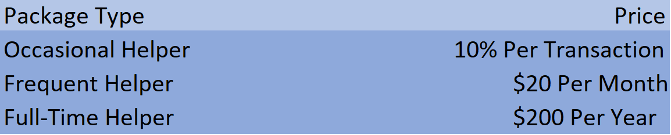Help! will collect its revenues from the service providers, giving three different options for a payment plan for the providers. The provided packages are designed for workers of different frequency. The details of each individual package are disclosed in section 7.2.

**7.0 Operations**

7.1 Business Facilities

Marketing

Office Exit/Entry

CEO Office

Developers

Developers

Bathrooms

Marketing

Developers

Developers

Marketing

CFO Office

Marketing

Marketing

CTO Office

Marketing

The Help! offices will be located in the Fremont area of Seattle at 255 S. King Street in the building known as Hawk Tower on the 18th floor. The office will be rented at the price of $2,109 per month, which is a really good deal considering the return on investment Help! will get from this office. The location will allow Help! to be close to students from the University of Washington and make networking with them much easier. The office will have individual offices for the executives and the marketers. To increase collaboration and teamwork, all of the offices will have glass walls looking outwards towards the rest of the desk. This will also give the office a modern feel which is incredibly important for a technology startup. The desks outside will be for the developers and they are in groups because there is proven to be 30% more productivity when developers work in open spaces where they can collaborate and solve problems as a group (StackoverflowBusiness). The office will have bathrooms, as well as a mini lounging area by the office entry.

7.2 Production Plan

Help! is a mobile application business, therefore, its major costs are early stage, and the rest of the costs of fixed. Its recurring costs will be in the personnel costs and the location costs. To ensure that those costs are at a minimum, Help! has chosen a location not in the downtown area of Seattle where offices are expensive, but still viable enough to reach the target market of high school students and stay-at home parents. Additionally, the employees hired will be mostly undergraduate students because of the relatively low starting salary compared to more experienced in the industry. As a side note, undergraduate students are more likely to take a risk and join a startup for a lesser salary in order to gain the experience.

Help! is going to offer multiple packages for users to start making money from the application. The key is making sure that our prices are not too expensive as to discourage customers to use the application all together. The main focus of Help! is to connect the world in the best way possible and the way to do this is to charge just enough money to cover the initial and fixed-long term costs. With this in mind, there will be no charge to people requesting services. There will only be small fees to those providing them. Here are the options.

Occasional Helper

This option is for people who don’t use Help! as much and would like to only pay a fee every time they do. For those people, Help! will take a 10% fee of the agreed upon price. This is less than the TaskRabbit fee and more reliable than Kadama’s financial structure. Initially, since there won’t be a huge volume of transactions occurring, the expectation is that the majority of Helpers will go with this package. Long-term, the expectation is that they will make up about 50% of the helpers.

Frequent Helper

This option will be designed for people who use Help! two to three times a week and would like to avoid the per-transaction fee. If that is the case, then the Frequent Helper package is the one for them. This package will give them the option to work with Help! on a fixed cost basis. Help! will offer a per month subscription of $20. From the customer’s standpoint, they would need to be making over $200 per month to be able to pocket more money than if they went with the Occasional Helper package. Given the expected average requesting offer of $15, this would require the customer to be completing 13 jobs per month which is very plausible for a frequent user of the app. In the initial stages, the expectation is that this group of Helpers will make a minority of the total helpers but in the long term, this should account for about 30% of all Helpers

Full Time Helper

This option will be designed for people who plan on working with Help! on a daily basis and would like to decrease their costs even more as to pocket more profit. The Full Time Helper package gives customers a subscription cost that will be taken on a yearly basis and will cost them less than the Frequent Helper package in the long-term. It will be priced at $200 per year, which would cut their costs by 20% from the annual total of $240 they’d be paying with the Frequent Helper package. At the average requesting price of $15, the Helper would be profitable after just 13 days of working if they worked every day. After that, all income would be profit, making them an additional $500 per month if they did only one job every day. Initially, Help! does not expect anybody to go with this plan, and whether this plan will be implemented in the first version is still being decided but once the application gains momentum, it is expected this group of helpers will make up about 20% of the Helper population.

7.3 Workforce Plan

Employees will be evaluated and selected by the executives in the early stages of the company. Once the company has broken even and is maintaining steady revenues and growth, the company will hire an HR & recruitment team responsible for the hiring process. As CEO, Zyad Elgohary will first find two co-founders, a CFO and a CTO, that will be excited to work in Help’s vision to unite the working world. The CTO should be technically capable, as they will be leading the team of developers, and the CFO should have some kind of background in Finance, Economics, or Business Administration. The executives should not expect to get paid for the first stages of Help, but they each will receive equity in the company. Initially, Help! will hire three developers and three marketers. The plan is, for each of those teams, one will act as a lead by having additional industry experience and the other two will be young, energetic undergraduate students. Each employee will fill out proper hiring paperwork and get evaluated biyearly to make sure their performance is exceptional. Help! will take it upon itself to ensure that all employees have a voice in the company, along with equal opportunity to make their mark in the business. Additionally, Help! will give standard costs of living raises, as well as additional bonuses of up to 10% based on job performance and job loyalty.

Company Hierarchy

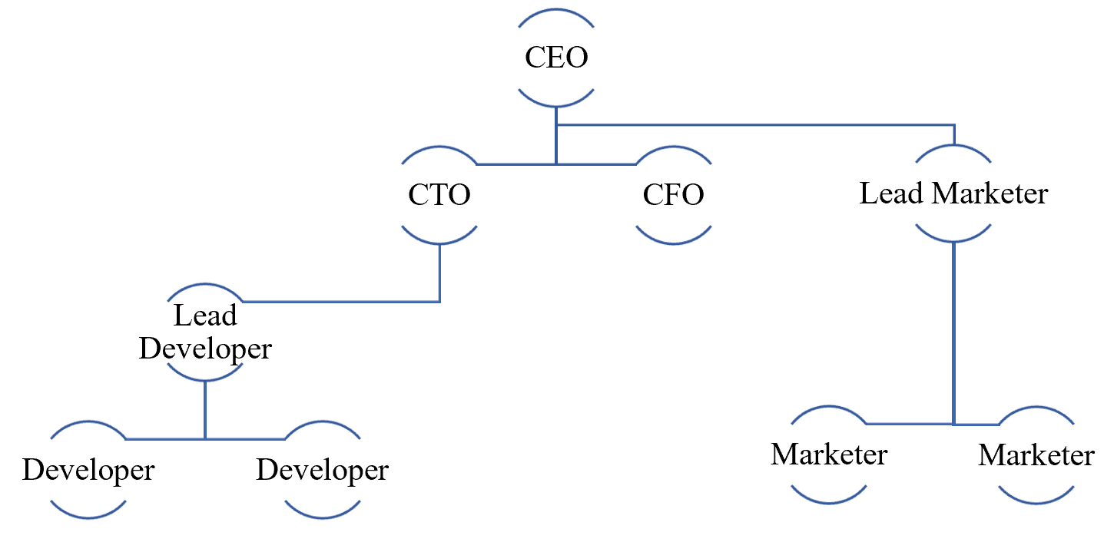

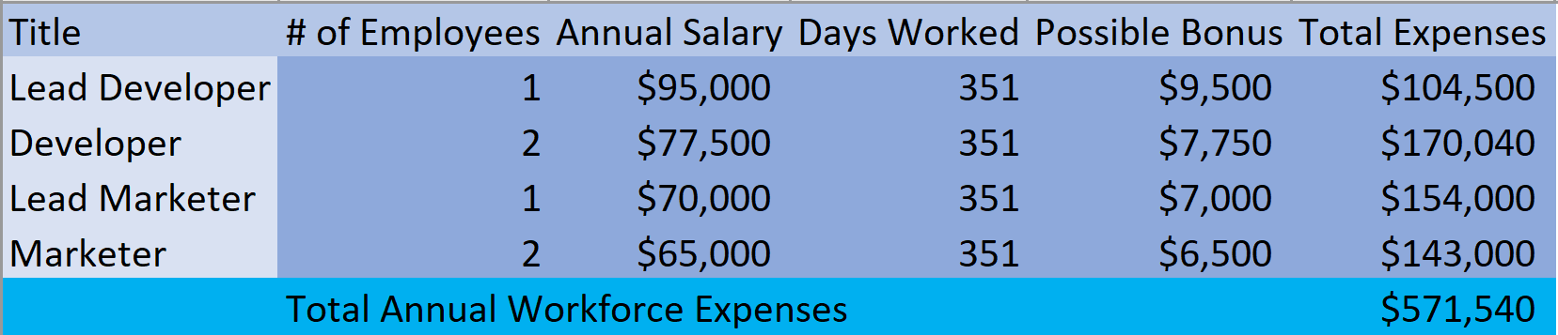Wages

Positions

Lead Developer

**Description**: The lead developer at Help! will be responsible for leading the initial team of developers in developing, maintaining, and updating the mobile application. As well as writing hard code, the lead developer will also implement project management techniques known in the industry such as using GitHub, Slack, and Agile/Scrum methods.

**Requirements**: A Help! lead developer should have 2+ years of experience in the mobile development industry. They should be comfortable with either Java, C#, or C++ as well as frameworks used for managing data within the mobile application such as Redux and React. Degree not necessary as long as entrepreneurship spirit is present. Since the lead developer will act as a manager to the other two developers, they should also have strong communication skills and be a capable leader able to communicate with both the developers under him, and the executives above him.

Developer

**Description**: A developer at Help! will take on the role of designing, testing, and developing the mobile application. They will work under the supervision of a development lead and the CTO of the company as they aid in the company vision through both programming and problem solving.

**Requirements**: Developers should have strong problem-solving skills as well as a curiosity to learn new technologies and skills. They should be comfortable with one of the big object-oriented programming languages (Java, Python, C#, etc.) and have knowledge of database solutions such as SQL, Redux, etc. They should be indulged in the company mission and show it with incredible hard work and dedication.

Lead Marketer

**Description**: Help’s lead marketer will be responsible for coming up with new branding, advertising, and marketing strategies. Reporting directly to the CEO, the lead marketer will find new ways to reach customers and will be personally tasked in forming new connections with the target market. They will be assigned to marketers to aid them in their goals and strategies. They will be evaluated by their creativity, customer growth, and other such aspects.

**Requirements**: The lead marketer should have 2+ years in real world experience and should have a background in marketing. When evaluated by the executives, the lead marketer will be searched for entrepreneurial skills, creativity, and most importantly, incredibly strong communication skills. They should be able to present, sell, and execute new marketing strategies. Additionally, they should have strong enough leadership and mentorship skills to be able to lead two other marketers with them on their path to customer growth.

Marketer

**Description**: A marketer at Help! will be responsible in executing the company’s marketing strategies. Working under the lead marketer, a marketer will network with customers, create new ad campaigns, and brand the company. The marketer should be passionate about the company vision and be very hard working and persistent in playing their role to make that vision a reality.

**Requirements**: The marketers at Help! should have a background in marketing, advertising, or a related field. This background can either be experience or education. They should be creative, good problem solvers, and quick thinkers. The marketing team should also have great communication & networking skills to be used when networking with customers.

7.4 Impact of Technology

As a technology startup, innovations and new ideas are at the core of Help’s beliefs. The company is going to implements new technology in every possible way. There is evidence that says humans are almost 300% more productive with modern, innovative technology (MatrixLMS). With that being said, Help! is going to adopt a methodology called PAADS. Here’s what it means.

Project Management

Project management is the idea of using teamwork, collaboration, and synergy to achieve maximum productivity. By using technologies such as Slack, AzureDevOps, GitHub, and Monday.com, Help! will communicate and complete tasks among teams quickly and efficiently in order to maximize employee productivity and product quality.

Accounting

Accounting is arguably the most important section of a company. Help’s CFO will handle all things financial, which include important figures such as debt, cash flow, and net income. To handle all of these numbers, the office will be set up with QuickBooks Premier 2019, the highest rated business accounting system in the world. By using this, the CFO will be able to save thousands, possibly millions, of dollars in taxes.

Architecture

In computer programming, proper design and architecture of an application is crucial. It is difficult to design and program an entire application in the most efficient way without using external technologies. Companies like Amazon and Magalix provide products that power your applications in the most effective way. Help! is going to be using AWS to power its application and will turn to Magalix in the future when it starts growing in order to access the cloud effectively. These AI products will cut costs for Help, making it a lot easier to reinvest profits into the company, and effectively improve the product.

Data

The world is currently data driven. The big data industry, which include tech giants such as Tableau Software and Microsoft Power BI, is transforming business intelligence and decision making. The executives at Help! will use Tableau Software to drive their decision making, using customer inputs and past data trends in Help! Using a data analytics platform, Help! is going to make much better decisions that will result in a better product for customers.

Social Platforms

Social platforms such as Instagram, Snapchat, and Facebook are what connect human beings to each other. Help! marketers are going to use these platforms as a primary way of reaching our customers, which happen to be majority students and young adults. With this strategy in mind, Help! is going to allow customers all around the world get their tasks done.

**8.0 Management & Organization**

8.1 Key Employees, Board of Directors, & Human Resources

The company will be structured as shown in the company hierarchy in section 7.3. Help! will exercise its legal right as an LLC to not have a board of directors, leaving all of the decision making in the hands of the executives. Here are the executives and their roles.

Chief Executive Officer

The CEO will handle long term development, control marketing strategies, and at the same time monitor the technical and financial side of the company. The CTO & and the CFO will report directly to him and all three of them will handle big decisions. In the early stages of the company, they will all act as the HR department of the company, taking care of the hiring process and the productivity factor of the company. The CEO will also be the face of the company, meaning he will speak on their behalf in conferences, interviews, and keynote presentations.

Chief Technical Officer

The CTO will be in charge of overseeing development of the mobile application. The development lead will report directly to the CTO and they will both work together in correctly building & structuring the architecture solution for the Help! mobile application. The CTO will also be responsible for using new technologies efficiently and adopting new innovations. The CTO will be a direct report to the CEO.

Chief Financial Officer

The CFO will be responsible for the financial side of the company. Using the modern QuickBooks accounting system, they will handle the company taxes as well as debt, cash flow, and other financial aspects. The CFO will report directly to the CEO and let him know the details and logistics of the company’s financial status.

8.2 Identifying, Securing & Recruiting Key Participants

The search for both qualified executives and employees will take place mainly online. The CEO will start off by putting out opening positions on recruiting sites and apps such as Indeed, Zip, and LinkedIn. In addition, Help’s location in Seattle places it in the vicinity of both the University of Washington and a multitude of big tech companies. This makes it possible to recruit industry workers and undergraduate students through networking with the location. The most qualified people will be young entrepreneurs who are willing to work hard and be patient in order to achieve success. Therefore, the job descriptions and interviews will be tailored accordingly.

8.3 Compensation & Incentive Plan

It is a known fact that happy employees equal productive employees. This means that certain policies and procedures must be in place to keep the Help! employees satisfied. As a startup, Help! is offering salaries that would be considered competitive for bigger companies as shown in section 7.3. Additionally, every year, employees have a chance to earn a 10% bonus according to their performance. While this may cost Help! a little bit extra in the beginning, the return on the investment in terms of exceptional job performance is well worth it. And finally, employees will be each given a code that allows them to work on Help! without paying anything. This gives them an opportunity to make even more money while working for the company. All of these incentives should keep employees motivated & passionate about the work they are doing. And as for the executives, the promise of wealth and impact due to the equity they receive is enough to keep them working towards the company vision.

**9.0 Long Term Development**

9.1 Goals

Short Term Goals

In the first three years of operation, Help! would like to secure a customer base large enough to sustain its costs. To do this, multiple factors must come into play. The executives will make sure that every decision they make in the first couple years of operation corresponding with these goals. Here is what Help! would like to achieve in the first three years:

* Attain a customer base of 2,000+ users by the end of the second year using SoLoMo strategies. With an expected average transaction cost of $18, and Help! taking 10% of the cost, this leaves $1.80 of revenue per transaction for Help! With the annual costs totaling to about $650,000 and transactions happening an average of two times a week, this adds up to requiring at least 2,000 users to becoming profitable. This idea is discussed later in section 10.6
* Establish partnerships with at least 3 local businesses for them to conduct all of their online business on the Help! platform
* Expand marketing efforts beyond the Puget Sound region in order to introduce to concept of Help! to other areas before fully focusing efforts to get people using Help! in the areas. Potential cities to expand to are Spokane & Portland

Long Term Goals

After breaking even in the second year, Help! will be in a more comfortable position financially to start working towards truly changing how people get tasks done. The executives will set the following goals to be achieved by the end of the seventh year of operation in order to increase profits, users, and the impact that Help! has on the world.

* By the end of the seventh year, Help! should have a customer base of 13,000+ users across multiple cities, the majority being in the Puget Sound area
* Have a presence in at least five cities beside Seattle. The best market fit would most likely be Portland, San Francisco, Austin, New York, and Los Angeles.
* Establish an HR department within the company, as well as hire at least seven new developers and seven new marketers
* Move offices to a new location and look to buy property instead of renting as to make revenues off of real estate in addition to the application. Offices will still be in Puget Sound

9.2 Risk Analysis

As a startup business of any kind, there are risks associated with growth. Beyond people simply just not liking the product, there are other kinds of risks that are more out of the company’s control. The key is to understand, analyze, and prepare for these risks. Underpreparing for risks with any business can be catastrophic and Help! will do everything in its power to avoid that.

Economic Risk

Recessions and bubbles have been present throughout history, and the results have been disastrous. In the internet bubble of the late 1990s, many businesses who were unprepared lost millions upon millions of dollars and the majority of companies sunk and filed for bankruptcy. However, strong companies such as PayPal, Amazon, Apple, and Microsoft successfully survived the crash that followed and some companies even used it to their advantage, buying back stock, and getting rid of unneeded employees. Elon Musk, co-founder of PayPal & Tesla Motors, said that the key to their survival was keeping a long-term vision and avoiding short term greed. CEO’s were trying to make as much money as possible and asking questions like “How can we gouge customers for as much money as possible in the shortest amount of time” when they should’ve been asking questions such as “How can we positively impact our customers for the next decade or so?” Using this philosophy, Help! will always set long term goals and visions and will take every single accordingly.

Financial Risk

As with any startup, finances are always an area of worry. Costs could either be too high or revenues could be too low. The CEO of Help! has, to the best of his ability, researched and detailed every cost and created projections of sales and profits based on growth expectations. All Help! executives will work together to ensure that these projections are met by either maintaining or reducing costs as well as making sure customer growth is steady and gradual. The CEO will work directly with the Help! marketing team to ensure that the correct procedures and strategies are being implemented to increase customer growth. Meanwhile, the CFO of Help! will continue to monitor costs through the accounting system, and make sure that growth is meeting expectations and letting the CEO know if they are not. Together, the CEO, CTO, and CFO will adjust marketing and development strategies to ensure that projections are being met.

9.3 SWOT Analysis

**10.0 Financials**

10.1 Accounting System



The CFO of Help! will handle the accounting for Help! using the QuickBooks Enterprise 2019 application. With the desktop application, the CFO will be able to create industry-specific reports, sales orders, and track costs for products and inventory. Additionally, the application allows the user to set product and service prices by customer type, which integrates perfectly with different packages Help! offers as described in section 7.2. QuickBooks Enterprise, although more expensive than other accounting services, provides robust tools for analysis, reporting, inventory, and pricing, making it the perfect accounting system to be used by Help!

10.2 Initial Expenditures and Investment Request

Help! will require some initial capital in order to sustain its operations for the first two years. Projections say that Help! will be able to sustain its costs some time in middle of the second year, which is discussed in section 10.6. The total costs for the first two years of operations have been calculated to be about $1.3 million. These costs are all previously discussed in this report such as data analytics, accounting, and personnel expenses. The CEO has agreed to put forward $250,000, leaving $1.04 million to be gathered through investors. The company has decided to ask for the investment from Madrona Venture Group, a venture capitalist in downtown Seattle. The investment will be an equity investment, as to avoid any loan payback and also to involve experienced business minds with Help! LLC. The agreed upon equity is 20%, valuing Help! at $5.2 million. With exponential growth through the wonders of the internet connecting the world together, this market capitalization is expected to grow to a billion-dollar valuation quickly. But as with any company, this takes time. With the company executives and Madrona Venture Group, steady revenue and customer growth shall come in time, and Help! will change how the world gets things done.

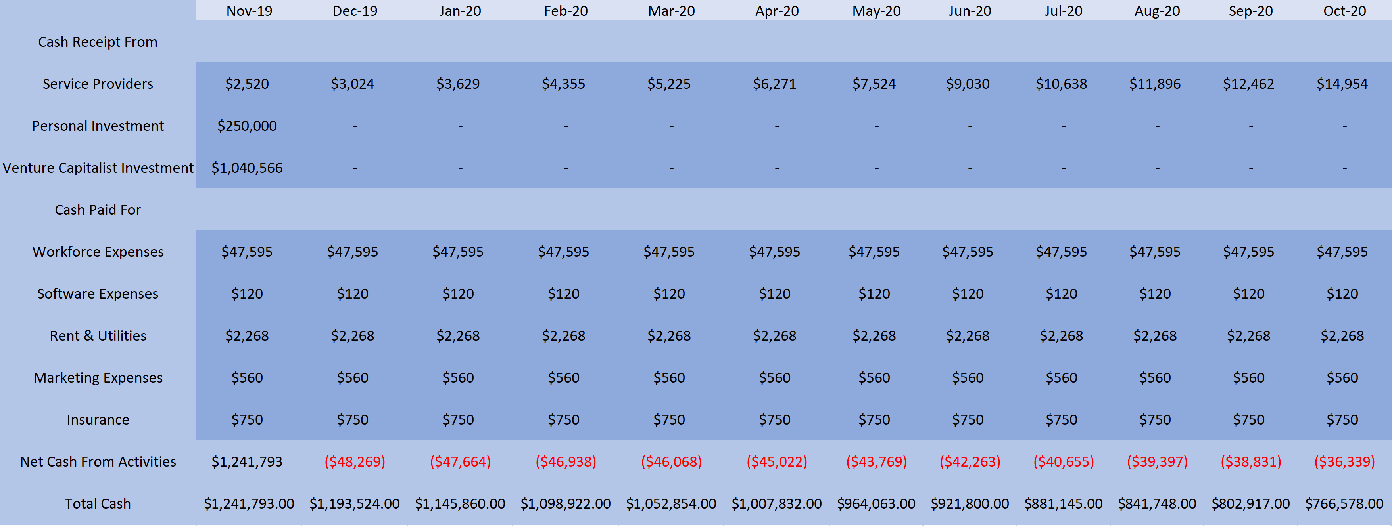10.3 Monthly Cash Flow Statements

10.4 Monthly Income Statements

10.5 Annual Income Statements

10.6 Breakeven Analysis

In order to break even, the company’s income must exceed its expenditures. With enough initial cash (discussed in section 10.2), Help! will be able to operate for the first two years at a loss. Near the end of the second year, it is projected that Help! will break even when it reaches about 2,000 users. By then, monthly revenues will be about $52,000. Monthly expenditures will remain fixed at $51,393. Once profits are achieved, the CEO plans to reinvest all of the profits back into the company, with long term plans to hire more developers and marketers, expand to new locations, buy real estate, and grow the Help! vision which is to empower people.

Return on Investment

As the graph above shows, with projected growth, the return on investment for the initial request of $1.04 million dollars is huge. As was the case with Facebook, Apple, and Microsoft, the initial investments grew multiple folds because of the accessibility of technology. By the end of the seventh year of operation, it is projected that Help! will be serving over 13,000 users resulting in a profit of $3.5 million, a 237% return on investment. From there, the growth is projected to be exponential, with the company reaching millions of customers across the nation. Here are the projected returns year by year.

**11.0 Appendix**

LLC Form Job Application Form

Investment Contract Form 9 Business Tax Form

**Works Cited**

Newberry, Christina. “23 Benefits of Social Media for Business.” *Hootsuite Social Media Management*, 2 May 2018, blog.hootsuite.com/social-media-for-business/.

The Dow Jones Transportation Average (DJT) -- the lesser known cousin to the Dow Jones Industrial Average -- has gained more than 9% this year. “Trains and Planes Are Booming. That's Good News for the Economy.” *CNNMoney*, Cable News Network, money.cnn.com/2018/09/17/investing/transportation-stocks-economy/index.html.

Ilyas. “Open Space vs Offices. Which One Is Better for a New Team According to Studies?” *The Workplace Stack Exchange*, workplace.stackexchange.com/questions/128935/open-space-vs-offices-which-one-is-better-for-a-new-team-according-to-studies.

Briggs, Jenny. “How Technology Is Making Us More Productive.” *MATRIX Blog*, MATRIX, 11 July 2018, blog.matrixlms.com/how-technology-is-making-us-more-productive/.